Langchain
LangChain is an open-source framework used to build agents and applications powered by Large Language Models (LLMs).

Components of Langchain:

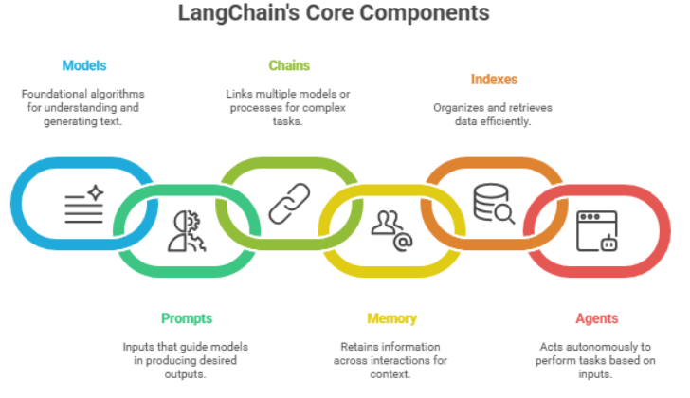

1. Models
Models are the core intelligence of a LangChain application.
Types:
- LLMs (Large Language Models) → generate text from prompts
- Chat Models → conversation-based models
- Embedding Models → convert text into vectors

2. Prompts (Prompt Templates)
Prompts define how instructions are given to the model.
Instead of writing hardcoded text repeatedly, LangChain uses templates.

3. Chains
Chains connect multiple components into a sequence.
Flow:
Input → Prompt → LLM → Output

4. Memory
Memory stores previous interactions.
Without memory:
User: My name is Ali
User: What is my name?
Bot: I don't know
With memory:
Bot: Your name is Ali

Purpose:
- Maintain conversation context
- Personalize chatbots

5. Indexes

a. Document Loaders
Load data from different sources.
Examples:
- PDF
- Website
- Text files
- CSV
- Word files

b. Text Splitters
Large documents must be split into smaller chunks because LLMs have token limits.

c. Vector Stores
Store embedding vectors and allow similarity search.
Popular vector databases:
- ChromaDB
- FAISS
- Pinecone
- Weaviate

d. Retrievers
Retrievers search the vector database and return relevant documents.
Purpose:
- Fetch useful context
- Used heavily in RAG systems

6. Agents
Agents allow the model to decide which tools to use.
- Instead of a fixed flow:
- Input → Output
- Agent:
- Input
↓
Reason
↓
Choose Tool
↓
Execute
↓
Answer

